Estimating the effect of number of remaining teeth on social participation among older adults in Japan

### ## Introduction

The term "social participation" refers to an individual's involvement in activities that allow them to interact with others in society or the community [@levasseur2010]. Social participation among older adults is regarded as an essential component of healthy aging because it has numerous positive effects on both individuals and society [@Golinowska2016]. Previous studies have linked higher levels of social participation to higher life expectancy, better health-related quality of life, well-being, and functioning of older adults [@Wanchai2018; @dahan2008]. Community-level health promotion and prevention activities such as physical activity, smoking and alcohol interventions are also facilitated through social engagement [@Saito2019]. On the other hand, wide range of determinants including health-related factors have been found to influence the level of social participation among older adults [@Cornwell2009]. `r '\n'`

Teeth and oral health play an important role in speaking, smiling, and facial expressions, which are essential for positive social interactions. Tooth loss is common in older adults as a result of a life-long accumulation of chronic dental conditions such as dental caries and periodontal diseases [@Griffin2012]. Previous studies have consistently linked social and neighborhood related factors such as social capital and social participation to oral health related outcomes among older adults [@Takeuchi2013; @Rouxel2015; @Aida2011]. However, it is equally important to understand the effect of oral health status on participating in social activities. To date no studies have investigated the impact of having more remaining natural teeth on social participation among older adults. It is not feasible to design a experimental study to quantify the effect of remaining natural teeth on a given outcome. Therefore, we used observational data to specify the causal effect of number of remaining teeth on social participation using a non-parametric approach that naturally satisfy the positivity assumption. `r '\n'`

Longitudinal modified treatment policy (LMTP) is a recently developed non-parametric alternative that can be used to define causal effects [@]. Traditionally, the literature around causal inference is based on binary exposures [@]. Categorisation of the exposure using a arbitrary binary cut point leads to loss of information on the exposure and impair the ability to observe any “dose-response” effect of the exposure [@]. However, using LMTP research question can be defined to quantify the effect of an intervention that shifts the observed level of exposure in each individual at to a new level [@díaz2021]. In other words, This framework can be adapted to quantify counterfactual outcomes for questions such as, "What would have happened to the prevalence of social participation if everyone in the study population increased or decreased their number of teeth by a certain amount?", "What if all edentate individuals receive dental prostheses", and "What if everyone loose their teeth?", utilising observational data. Furthermore, the corresponding statistical estimates for LMTP can be estimated using sophisticated doubly-robust statistical estimators [@lmpt ref], such as the targeted minimum loss-based estimation (TMLE) with Super Learner , which allows for the use of flexible machine learning predictions avoiding parametric modeling assumptions [@Laan2011].`r '\n'`

This study presents an analysis that estimates the effect of number of remaining teeth on social participation among older adults while taking the time-varying nature of variables into account. We used LMTP to dynamically shift the level of exposure (number of remaining natural teeth) as a deterministic function of the observed level of the exposure in order to investigate its effect on social participation among functionally independent older adults in Japan during 6 years of follow-up. A higher number of teeth would, presumably, have a positive impact on social participation. Hence, we hypothesised that as the number of teeth increases, social participation improves, and as the number of teeth decreases, social participation declines among older adults. `r '\n'`

## Methods

### Data

Data from the Japan Gerontological Evaluation Study (JAGES) was used in this study [@Kondo2018]. JAGES is an on-going nationwide cohort study for functionally independent older adults in Japan aged 65 years or over. For this analysis, data from the 2010 survey as the baseline and two subsequent follow-up surveys (2013 and 2016) were used. A total of `r n_baseline` functionally independent individuals were identified at the baseline survey. Out of them `r n_base_to_16` individuals had responded to all three waves of JAGES (i.e. 2010, 2013, and 2016). During the 6 years of follow-up `r n_died` had died, `r n_ineligible` became ineligible as they became functionally dependent, and `r n_lost` were lost to follow-up due to other reasons. A comparison of baseline characteristics by participants follow-up status (i.e. died/ became ineligible/ lost to follow-up/ remained) is reported in Supplementary Table 1. `r '\n'`

After excluding participants with missing information for number of teeth in 2010 (n=`r nmis_A0_teeth`) and social participation in 2016 (n=`r nmis_Y2`) a total of `r N` participants were included in the analyses. The selection of the analytical sample is shown in Figure 1. Baseline characteristics of the participants who were excluded due to missing information are compared in Supplementary Table 2. `r '\n'`

#### ### Outcome variable

Social participation in 2016 was the outcome in this study. JAGES recorded the frequency of participation (“nearly every day,” “twice or thrice a week,” “once a week,” “once or twice a month,” “a few times/year,” “never”) for various social activities. We assessed the frequency of participation in any of the following activities: hobby groups, sports clubs, senior citizens' clubs, residence groups, or volunteer groups. Participation in any of the aforementioned activities once a month or more frequently (vs. less frequently or never) was defined as indicative of social participation (1 = participation, 0 = non-participation). `r '\n'`

#### ### Exposure

The number of remaining natural teeth at the time of the surveys in 2010 and 2013 was used as a time-varying exposure in our analyses. The self-reported number of teeth was recorded using the response to the question, "How many natural teeth do you currently have?" (Instructions: capped/crowned teeth should be counted as "natural teeth"). The responses of participants were recorded in four categories (i.e., 20 teeth/ 10-19 teeth/ 1-9 teeth/ no teeth). `r '\n'`

#### ### Covariates

As the number of teeth was assessed as a time-varying exposure in the analysis, both time-invariant and time-variant covariates were controlled for. Age (range 65-99 years), sex (male/female) and social participation in 2010 (baseline outcome) were adjusted for as time-invariant covariates. As time-variant covariates, equalised annual household income (million yen), instrumental activities of daily living (IADL) score (0-13), and marital status (married/ single, widowed or divorced) were used (measured in 2010 and 2013). `r '\n'`

*### Statistical analysis*

The directed acyclic graph (Figure 2) depicts hypothesised temporal relationships between study variables. A descriptive analysis was performed to identify the characteristics of participants stratified by the outcome (social participation in 2016). Then, to specify the impact of number of teeth on counterfactual outcomes, the observed level of number of teeth of each individual was shifted to several new levels to mimic multiple hypothetical interventions. Following hypothetical scenarios were created by shifting the observed exposure to detect any dose-response associated with the outcome. `r '\n'`

1. “all participants having ≥20 teeth in 2010 and in 2013,” (i.e. ideal counterfactual scenario where all the participants having a minimal functional dentition [@who])
2. “all participants having 10-19 teeth in 2010 and in 2013,”
3. “all participants having 1-9 teeth in 2010 and in 2013,”
4. “all participants being edentate in 2010 and in 2013,” (i.e. worse counterfactual scenario where all the older adults were edentate)
5. “observed level of number of teeth category” (i.e. originally observed data in 2010 and in 2013).

To estimate the social participation with the shifted (and the observed) exposure, we used TMLE [@diaz; @Schuler2016]. In TMLE, the probability of the exposure conditional on covariates (exposure model), and the conditional probability of the outcome given exposure and covariates (outcome model) were estimated to obtain an unbiased estimation of the counterfactual outcomes [@Laan2006; @Schuler2016]. If either the exposure model or the outcome model was consistently estimated, unbiased estimates could be obtained (hence doubly-robust) [@Laan2012]. To increase the likelihood of robust specification of exposure and outcome models, Super Learner, an ensemble method that uses weighted combinations of multiple machine learning algorithms was used [@Laan2007; @Rose2019; @Schomaker2019]. Within Super Learner, generalized linear models, extreme gradient boosting models, and neural nets were used as candidate algorithms. [@Venables2002; @Chen2016] `r '\n'`

Then, the TMLE estimate for the ‘ideal’ counterfactual scenario (i.e. all having a functional dentition at each time point) was used as a reference to calculate causal odds ratios (OR) and 95% confidence intervals (95% CI) for other respective scenarios.

Additionally, to investigate whether the dental prostheses use (i.e. use of fixed or removable artificial teeth to replace missing natural teeth) modify the ( has any effect on social participation among older adults. To investigate the effect of dental prostheses within each number of teeth category, two hypothetical scenarios were defined using using LMTP: (1) all participants (in their respective number of teeth category) using prosthesis in 2010 and in 2013, and (2) none of the participants using prosthesis in 2010 and 2013. To calculate ORs and 95% CIs in this stratified analysis, the firstscenario in which no one wears dentures was used as the reference. All estimates were appropriately controlled for aforementioned time-variant and time-invariant covariates.

For imputation of missing data in covariates, we used random forest multivariate imputation by chained equations (MICE). In imputing complex epidemiologic data, random forest MICE has been shown to produce less biased parameter estimates and better confidence interval convergence compared to parametric MICE [@Shah2014]. We performed our analyses using five imputed datasets and the results were pooled using Rubin’s rules. Random forest MICE was implemented using `*mice`* R package [@Buuren2011]. The distribution of missingness among covariates is reported in Supplementary Figure 01.

The `*lmtp`* R package was used to compute TMLE estimates with SuperLearner for each hypothetical intervention [@lmtpR]. Main R functions used to generate our results are provided in appendix xx. All the other codes that used for data preparation and supplementary analyses can be found at `https://github.com/upulcooray/socialParticipation`. All the analyses were conducted in R studio using `*R version 4.1.2`* for x86_64, linux-gnu.

### ## Results

Baseline characteristics of the sample stratified by the outcome variable are presented in Table 1. In the 2016 follow-up, 11,762 people reported a frequency of at least once a month social participation. Baseline characteristics associated with social non-participation in 2016 were older age, lower income, lower IADL score, being edentate, and lower frequency of baseline social participation.

Figure xx contrasts the mean prevalence estimates (TMLE estimates) of social participation related to various hypothetical intervention policies with the prevalence estimate (TMLE estimate) of social participation in the observed data without any intervention. Having a relatively lower number of teeth negatively affected social participation after the six-year follow-up. After adjusting for age, sex, baseline social participation and time-varying confounders such as annual household income, IADL score, dental prosthesis use, and marital status, consistent exposure to edentulousness would have lowered the mean social participation by 9% (OR= 0.91 & 95%CI= 0.84,0.99). Similarly, the odds of social participation were lower if the dental status of everyone in the sample population deteriorated by one step (see hypothetical intervention No.5 in the methods section) in terms of number of teeth category (OR= 0.91 & 95%CI= 0.86,0.96). On the other hand, continuously being in the 20 or more teeth category (having a minimal functional dentition) increased the odds of social participation by 9% (OR= 1.09 & 95%CI= 1.07,1.11).

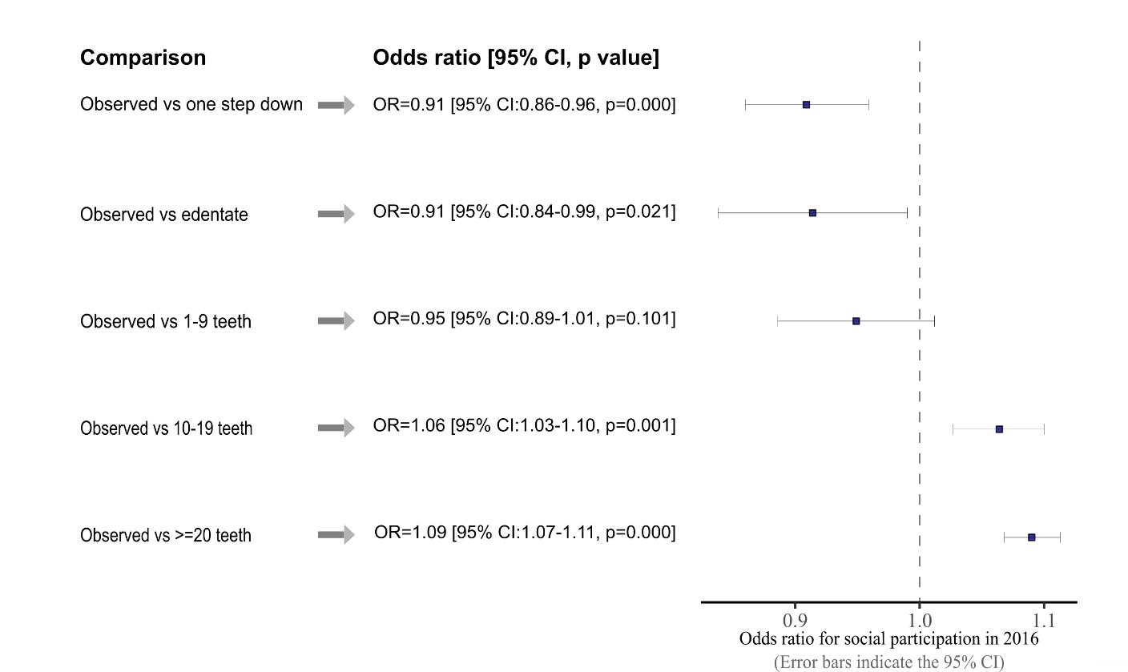

[Figure caption: Odds ratio for social participation under different hypothetical interventions (no intervention as the reference): OR,95% CI, p-value]

Results related to the effect of dental prosthesis use on social participation for the different number of teeth categories are shown in Figure xx.

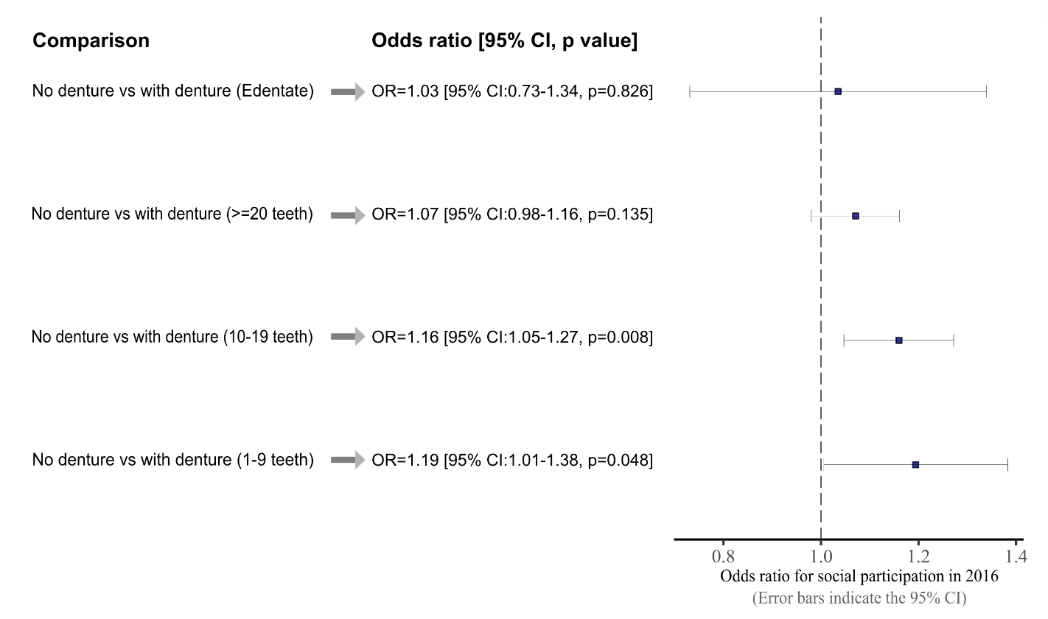

[Figure caption: Odds ratio for social participation for different number of teeth categories under hypothetical denture status levels (observed denture status as the reference): OR,95% CI, p-value]

The overall trend of the results indicated that dental prostheses had a positive effect on social participation across all number of teeth categories. However, the findings revealed that a significant beneficial effect of denture use on social participation could only be found among the 10-19 and 1-9 teeth categories (OR= 1.16 & 95%CI= 1.05,1.27; OR= 1.19 & 95%CI= 1.01,1.38, respectively). Social participation among the edentate group and those with more than 20 teeth did not appear to be affected by denture status.

### Discussion

Using an analytic approach that enabled assessing the effect of different levels of an exposure over time while adjusting for time-variant covariates, we estimated the effect of dental status on social participation. A doubly-robust estimator (TMLE) in combination with machine learning based ensemble (SuperLearner) was used to obtain the estimates. To the best of our knowledge, this is the first study to estimate the effect of number of remaining natural teeth on social participation.

Our analysis revealed that having a relatively higher number of teeth during the follow-up period improved the social participation among older adults in our study population. Being edentate and experiencing consistent tooth loss during the follow-up period reduced social participation. Furthermore, our findings suggest that wearing dentures would improve social participation among older adults with 1-9 teeth or 10-19 teeth. Dentures did not appear to provide a significant benefit to edentate people in terms of improving social participation.

Our findings are consistent with prior studies related to the link between oral health and social participation [@]. However, previous studies were based on cross-sectional data and treated oral health as the dependent variable. Our analysis gave insight into how number of teeth would affect social participation using longitudinal data. Given the evidence that social participation improves the health and well-being of older adults, any mechanism that leads to increased levels of social participation should be promoted and encouraged [@]. In that context, our findings emphasise the importance of older adults retaining a higher number of teeth, not only for obvious benefits on oral functions such as mastication and speech, but also to have better social relationships and thus reap the benefits associated with social participation.

The analysis, which was intended to investigate if the dental prostheses could improve the social participation, identified that the benefit of dentures was limited to those who had 1-9 teeth or 10-19 teeth. These two groups are unique as these groups represent relatively unstable status of the dentition compared to individuals in >=20 teeth category or edentate state. It is plausible that these two groups are more susceptible to the challenges posed by impaired oral functions as a result of tooth loss. Edentate people, on the other hand, transition into their edentate state over a long time period, so their baseline level of social participation may already be established, making them less likely to be affected by dental prostheses. Overall, these findings suggest that preventing tooth loss in order to maintain a minimum functional dentition in older adults would be more effective than providing dental prostheses in terms of improving social participation.

The use of a doubly-robust TMLE estimator to estimate the effects of multiple hypothetical interventions that are otherwise unmeasurable, can be considered the study's main strength. Furthermore, our estimates were based on longitudinal data while allowing for the time varying nature of the exposure and confounders. However, several limitations should be noted. Variables used in this study were based on self-reported measures, which are prone to measurement and classification errors. However, previous studies conducted in Japan have shown the validity of self-reported number of teeth [@Matsui2016; @Ueno2018]. Causal inference for time-varying exposure necessitates no unmeasured confounding assumption at each time point (conditional exchangeability assumption). Despite the fact that we adjusted estimates for multiple time-varying and time-invariant confounders, as well as baseline levels of social participation, the possibility of unmeasured confounding cannot be ruled out. In our analyses we used panel data with participants who took part in all three waves of the JAGES. Therefore, we had a large attrition of our sample population (n= 52053 at baseline to n= 22451 at 2016 follow-up). We examined the baseline characteristics associated with attrition (supplementary table xx) and showed that it was associated with a lower number of teeth at baseline. However, a low number of teeth negatively affected social participation, thus, any selection bias caused due to attrition would have led to an underestimation of the effects of tooth loss on social participation.

In this study, we only looked at the effect of number of teeth on the frequency of social participation. However, the quality of social interactions is just as important in accruing the health benefits of social participation [@]. It is reasonable to assume that the quality of social interactions is more affected by teeth and oral health than the frequency of participation. Therefore, further research is warranted to investigate this assumption. Moreover, we were not able to identify the locations of missing teeth in our data. Missing front teeth would have had a greater impact on facial aesthetics and speech, whereas missing posterior teeth (molars and premolars) would have mainly impacted masticatory functions. Thus, the location of missing teeth would have affected differently on social participation. These effects should be further investigated in future studies.

### Conclusions